**mongodb://127.0.0.1:27017**

**Test missing userId:**

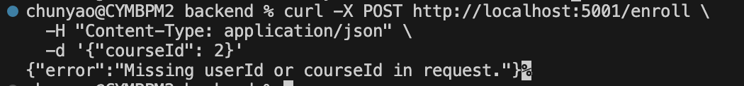

**Test missing courseId:**

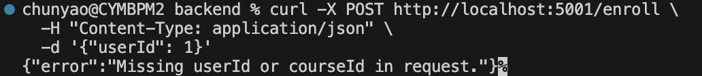

Test Enrol

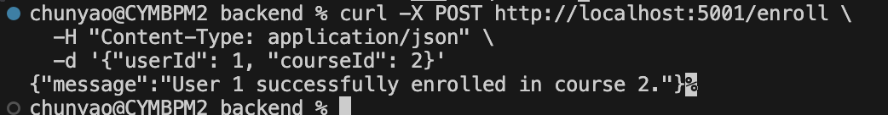

**Project-Specific Commands (Run from SPECIFIC folders)**

These must be run from the correct project directory:

**Backend (Node.js/Express) commands:**

bash

# MUST be in your backend folder

cd /Users/chunyao/Desktop/My\ Files/Training/NUS\ Full\ Stack\ Fundamentals/Capstone/backend

# Then run:

npm run dev

npm install express

**Frontend (React) commands:**

bash

# MUST be in your client folder

cd /Users/chunyao/Desktop/My\ Files/Training/NUS\ Full\ Stack\ Fundamentals/Capstone/frontend/ai-lms/client

# Then run:

npm start

npm install react-router-dom

**MySQL Commands:**

bash

# MySQL client can be run from ANY folder

mysql -u root -p

# But SQL commands are run INSIDE MySQL:

USE lms_db; # ← This runs inside MySQL

CREATE TABLE users; # ← This runs inside MySQL

## ****For Your Current Tasks:****

1. **MySQL commands**: Run from any folder, but SQL executes inside MySQL
2. **Backend server**: Run from Capstone/backend/ folder
3. **Frontend server**: Run from Capstone/frontend/ai-lms/client/ folder

So for your database tasks, you can open Terminal from anywhere and run mysql -u root -p, then 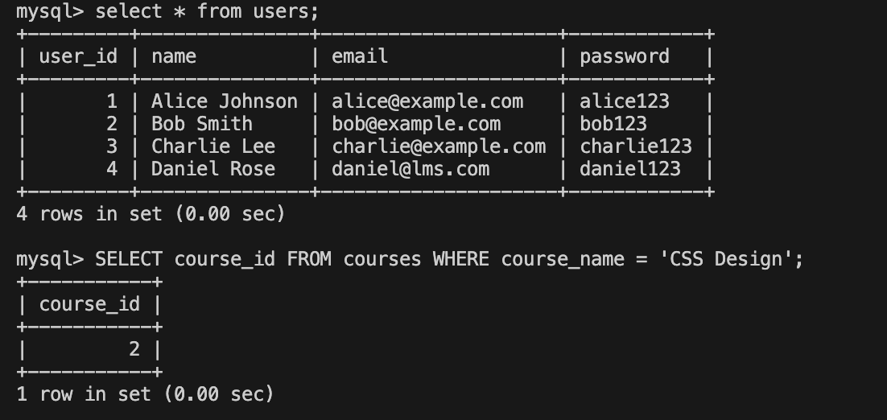execute all the SQL commands inside MySQL! 🐬

Enroll

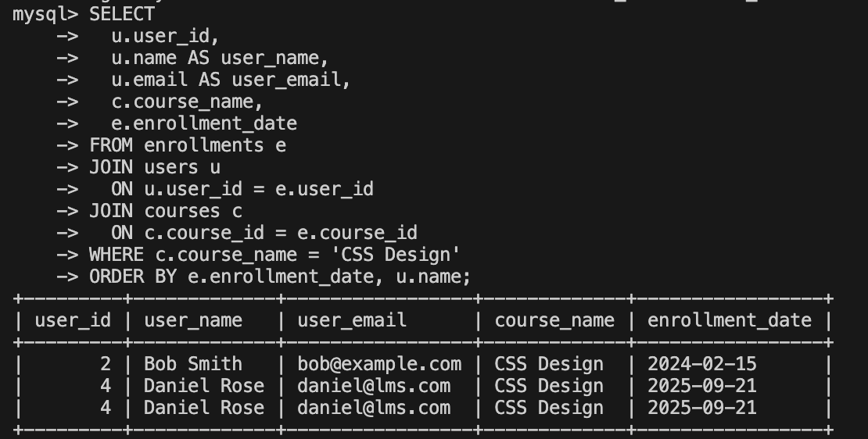

CRUD exmaples

REad

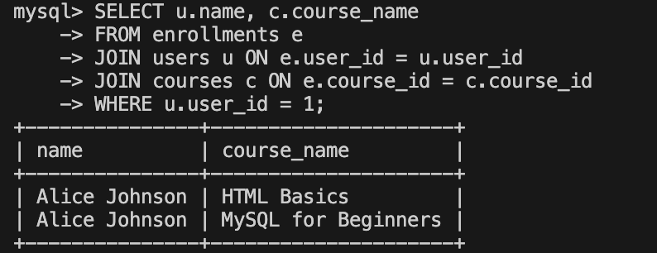

Update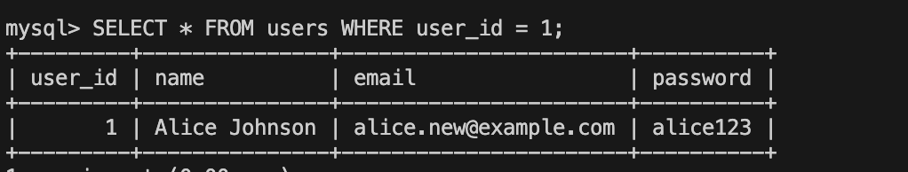

Delete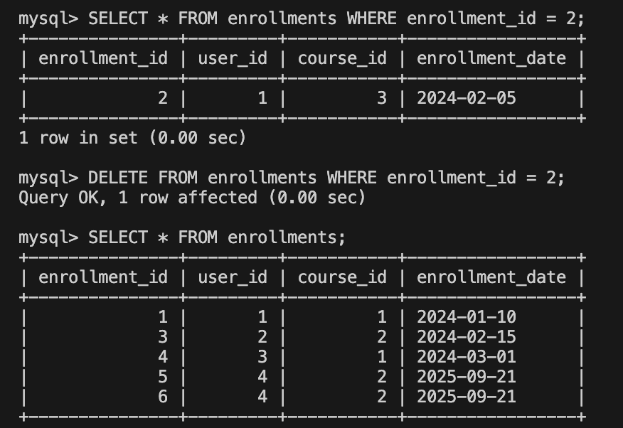

Display all users enrolled in CSS 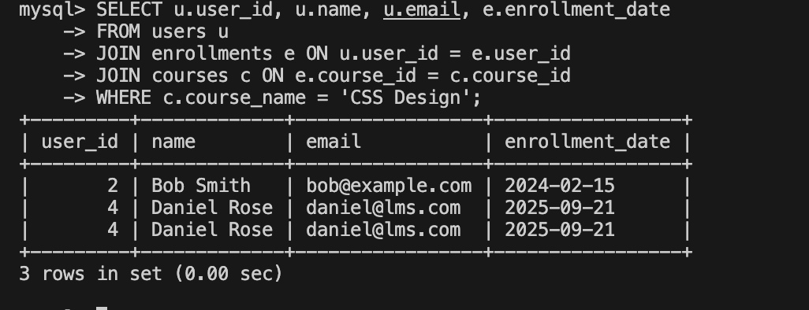

MongoDb

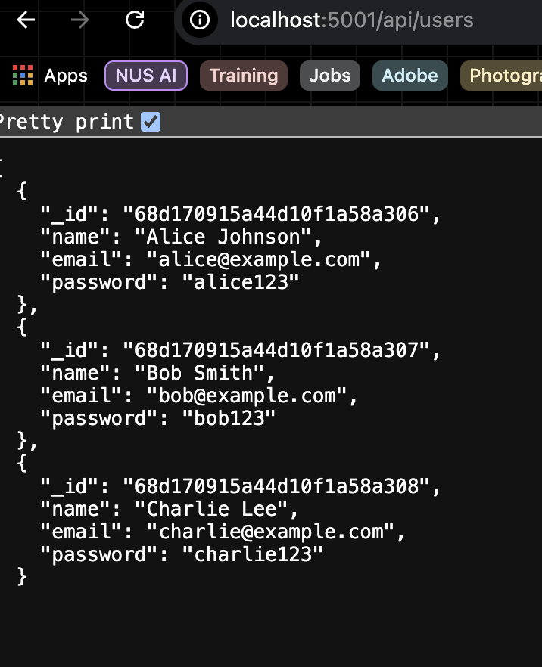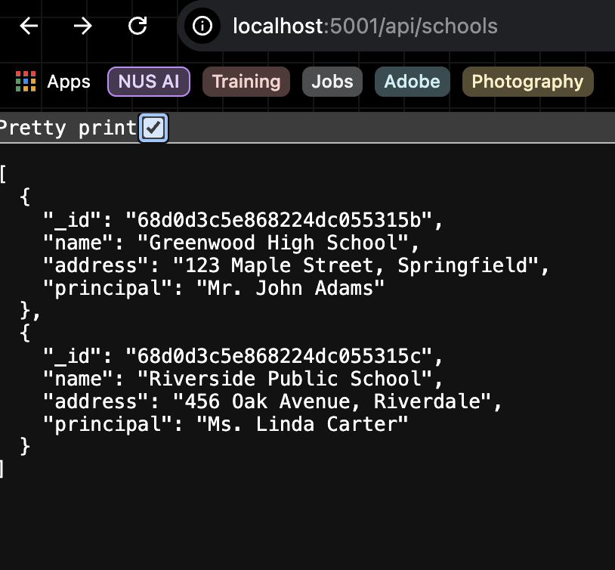

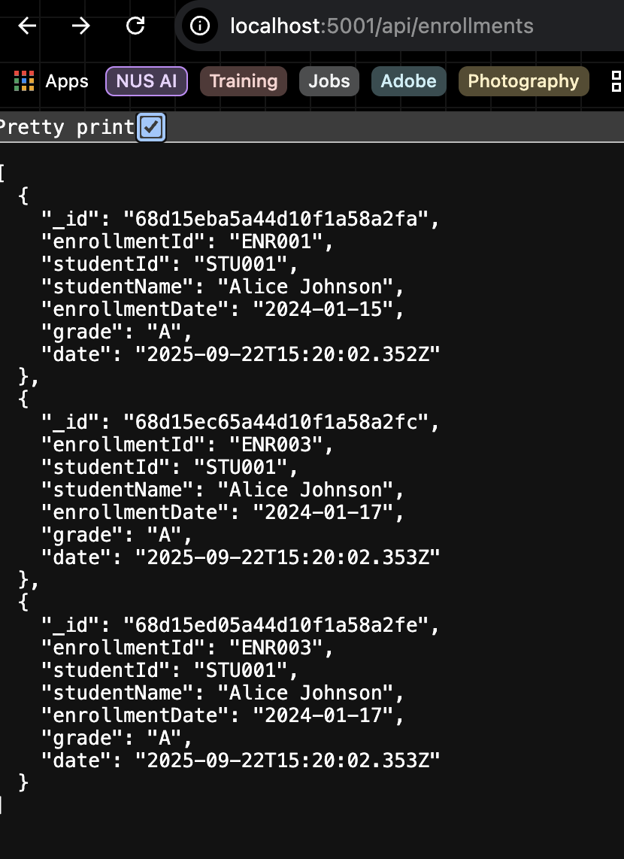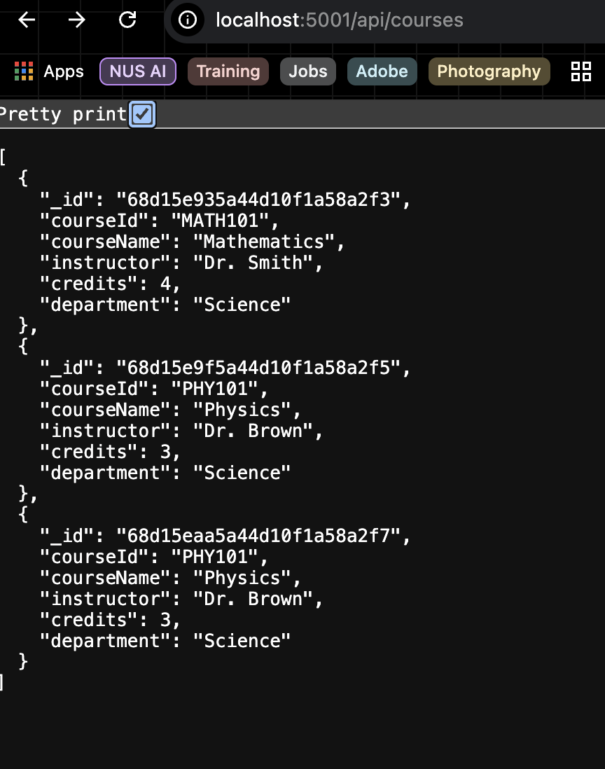

**Now perform the below task:**

1. Create a new entry in ‘school’ in MongoDB database and insert a document with the following parameter:

* “_id”
* “name”
* “address”
* “principal”

**Hint:**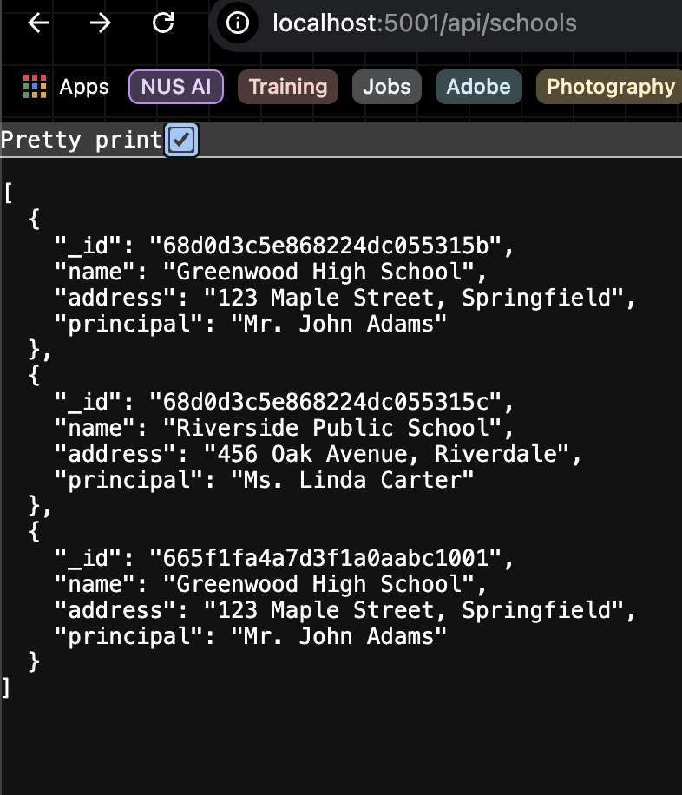

* Use MongoDB Compass
* Use “ADD DATA”